Step by step - How to pick your courses and set up your schedule at WUR?
Step 1: decide in which semester or period you want to take your courses:
- In case of a minor: schedule the Compulsory Courses and decide wich Restricted Optionals you are going to take.
- In case or separate courses: go to the course catalogue and select your courses (see step 2 for level);
- Period 1 and 2 allow for 12 ECTS each, period 3 for 6 ECTS;
- Period 5 and 6 allow for 12 ECTS each, period 4 for 6 ECTS;
Schedule one morning course (MO) of 6 ECTS and one afternoon course (AF) of 6 ECTS in the longer periods. Period 3 and 4 have whole day (WD) courses of 6 ECTS.
- Check more carefully with courses of 3 ECTS, they can be scheduled differently;
- WUR minors are 24 ects. When you have to fill 30 ects for your programme, pick an extra course, either from the minor if possible (Restricted Optionals) or from the course catalogue;
- Check this site or use this academic calendar to make your planning:

Academic year - schedule
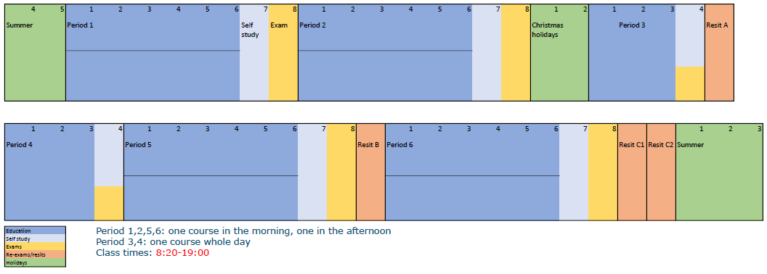
Please note that most courses at WUR are time-intense, with many practicals, tutorials and work groups. They are all mandatory, only Lectures (hoorcolleges) are usually not compulsory (check the course description in the course catalogue to be sure). So it is hardly possible to schedule two courses at the same time.
Step 2: after you’ve found courses of your interest, please check:
- Is it the right level? WUR doesn’t have specified bachelor’s or master’s courses. See below this page for the course codes explained*.
- Is there any assumed knowledge? (see under Course Description). Do you have this knowledge? If not, reconsider your choice;
- Is it offered in the right period and time? Can the courses be combined?;
- Is there a maximum of students for this course? If so, choose an alternative course in case you’re not admitted;
- And have your programme checked with you own study advisor or exam board.
Step 3: register as a bijvakstudent
- You only need a copy of your ID and a Bewijs Betaald Collegegeld (BBC);
- If you want to take a minor in the first semester of the next academic year, make sure you register at your own university or hbo for the next year as soon as possible. If you are not registered at your own university or hbo, you cannot yet be admitted as a bijvakstudent;
- Recommendation: register for the AID (introduction days) via https://www.aidwageningen.nl/ or come to the information session in August/February for bijvakstudents.
Step 4: register for the courses
- Received your WUR account? Go to Osiris and enroll for the courses you want to take. Not received a WUR account while you should have? Send an e-mail to ssc@wur.nl.
Step 5: schedule in TimeEdit
- Go to Huidige Studenten / Current Students and Study handbook and schedule for more useful information during your time at WUR.
Step 6: come to the campus for your first lecture!
*Course codes explained
Course codes have a standard format: AAAXxxbb (e.g. ESA20806)
AAA = abbreviation of responsible chair
First number/X = the level of the course. Between brackets what it more or less corresponds with.
1= introductory (1st year BSc)
2= continuing (2nd/3rd year BSc, sometimes 1st year MSc)
3= in-depth (3rd BSc or MSc)
4= courses for master’s students only
5= capita selecta (level depends, mostly 2nd/3rd year BSc)
6= Academic Master Cluster (1st MSc, not for external students)
7= internship (2nd MSc, not for external students)
8= thesis (2nd MSc, not for external students)
9= course by endowed chair
xx = used to make codes unique (no specific meaning)
bb = number of credits

Need more help or information? Send an e-mail to info.minors@wur.nl.

