Group: Host-Microbe Interactomics (HMI), Organic Chemistry (ORC)
Project: Identification of natural antibiotic compounds produced by rhizosphere bacteria from the Algerian desert
Supervisors: Peter van Baarlen (HMI), Laura Righetti (ORC)
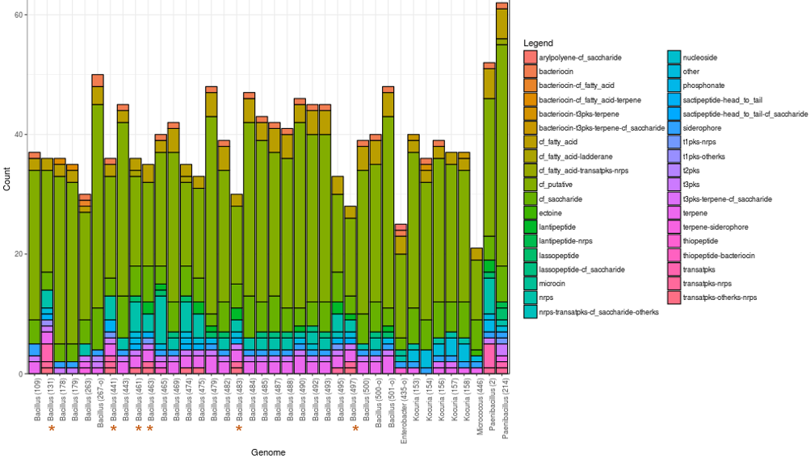
Background and research interests - Bacillus bacteria from the species B. halotolerans and B. subtilis were collected from the rhizosphere of the plant Zygophyllum album growing in a saline desert area in the south of Algeria. The genomes of these isolates showed various biosynthetic gene clusters and interesting in vitro antagonistic activity against Verticillium dahliae, Fusarium, Phytophthora and Rhizoctonia, From these Bacillus strains, 6 strains (red asterisks in figure) had antagonistic activity against all 4 pathogens, as well as good tolerance to hydrogen peroxide and 3 different antibiotics.
We expect that the isolates might produce multiple metabolites in vitro. In silico analysis has predicted what sort of molecules could be produced by the isolates.

Objectives
The aim of the study is to identify and characterize the metabolites produced by the isolates.

Methodology / what students can learn
Students will grow the nonpathogenic Bacillus isolates in liquid cultures for sufficiently long times to allow for production of bacterial metabolites. The liquid culture will be analyzed using liquid chromatography coupled to high resolution mass spectrometry with the aim to identify metabolites and correlate their presence with the biological activity.

Requirements
We are looking for MSc students interested in learning basic microbiological and more advanced analytical techniques. The project will have a duration of 6 months.

Contact information
Laura Righetti, Organic Chemistry, Agrotechnology and Food Sciences - laura.righetti@wur.nl
Peter van Baarlen, Host-Microbe Interactomics, Animal Sciences - peter.vanbaarlen@wur.nl

