Contact persons | Federico Andreotti (FSE) – federico.andreotti@wur.nl  Valentina Tassone (ELS) – valentina.tassone@wur.nl

Title | Fostering social-ecological learning through board games  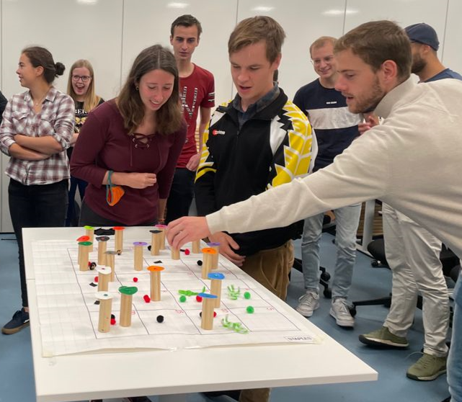
Information | Serious games are a well-developed participatory research tools to learn about, discuss and explore social-ecological complexity. By playing a game that mimics part(s) of the real system, stakeholders explore the potential impacts of their actions, while sharing their knowledge and understanding of the functioning of the system at hand. Further, co-designing serious games with research participants open the opportunity to establish an iterative process in which multiple stakeholders perspectives are combined into a learning and scenario evaluation tool.  While “already made” games (i.e. Rehab, Resortes games) on social-ecological complexity are played in education, few lecturers have challenged the students to design a game as an assignment for a course. During Period 5, March-May 2023, in the course FSE-32306 Methodologies for Reading Sustainable Foodscapes, (also known as “Redesigning global farming and food systems”), the students will redesign a farming or a food systems, by developing scenarios and designing a board game as a “companion” and final assignment. Further this course involve MSc students from natural and social sciences creating an interdisciplinary learning community.  This MSc thesis project will study the students game design process and explore the learning experiences and impact of co-designing a board game to address socio-ecological matters of concern.  The project will be supervised by the Farm Systems Ecology Group (FSE) and Education and Learning Sciences (ELS) chair groups. The MSc thesis student working on this project will receive the advice of an interdisciplinary team of the Centre for Unusual Collaborations (CUCo) on the “Spark” project entitled “[UN]BOX: Unpacking, cocreating, and materialising collaborative research processes for shared learning, purpose and impact”.
Main Objective of the MSc thesis project:

- Study the game design process and explore students’ learning experiences and outcomes, in a longitudinal fashion including 1.intended to 2.implemented to 3.attained results of the game co-design process to respond to socio-ecological matters of concern

Literature

- Andreotti, F., Speelman, E. N., Van den Meersche, K., & Allinne, C. (2020). Combining participatory games and backcasting to support collective scenario evaluation: an action research approach for sustainable agroforestry landscape management. Sustainability Science, 15(5), 1383-1399.
- Page, C. L., Dray, A., Perez, P., & Garcia, C. (2016). Exploring how knowledge and communication influence natural resources management with ReHab. Simulation & Gaming, 47(2), 257-284.
- Tassone, V. C., O’Mahony, C., McKenna, E., Eppink, H. J., & Wals, A. E. (2018). (Re-) designing higher education curricula in times of systemic dysfunction: a responsible research and innovation perspective. Higher Education, 76(2), 337-352.
Requirements

- Enthusiasm for the topic
- Good facilitation and communications skills
- Interest in participatory research methods
- Willingness to work with especially qualitative and partly quantitative analysis

The MSc thesis project would start preferably in mid-February/ beginning of March 2023.

