Instructions for candidate students of the BSc Honours Programme
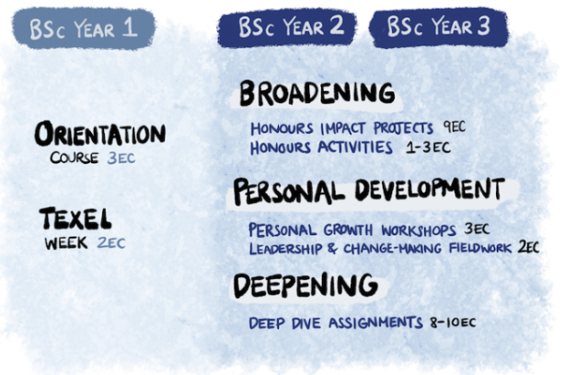
The BSc Honours Programme is for students who want are able to go the extra mile. The Honours Programme is extra-curricular and on top of the regular study Programme. It has a workload of 30 credits. There is one Honours Programme for the entire Wageningen University and it exists of the following pillars: broadening, deepening, personal development & leadership.
Honours is looking for highly motivated, creative and talented first year BSc students with a broad interest in the domains of life sciences.

The following application criteria have been set and have to be met in order to apply for the Honours Programme:
- First year bachelor student Wageningen University
- Special interest in broadening, deepening and personal development & leadership
- Ambitious, active, motivated and open-minded
- Distinctive activities outside high school, regular BSc Programme (sport, music, art, reading, job, voluntary work …)
- Move through the study smoothly
Application and selection for the Honours Programme is done in two steps:

Step 1: Enrol in and attend the Honours Orientation Course
If you are applying for honours, you first apply for the orientation course. This course consists of four evenings in period 5 in the Forum building on Wageningen Campus. Exact dates will be confirmed soon on our website. During the orientation course you will find out whether the honours programme suits you and whether you want to join the honours programme in your second and third year of your bachelor's degree.
- Letter of motivation (in English or in Dutch)
  - Which specific interests do you have in the Honours Programme?
  - What would you like to learn and what can others learn from you?
- Curriculum Vitae (CV)
  - Personal information
  - Education so far
  - Experiences outside high school (voluntary work, work experiences,……)
- Write a narrative (300-400 words) in which you take a point of view, based on arguments that makes people think. The topic is free.
Send the application latest 25 February to: honours@wur.nl
Step 2: After attending the Orientation Course, you can apply for the Honours Programme.

