Group: Wageningen Food Safety Research (WFSR), Organic Chemistry (ORC)
Project: Analysis of Pyrrolizidine Alkaloids in Jacobaea species
Supervisors: Laura Righetti (ORC/WFSR), Leonie Straub (ORC/WFSR)
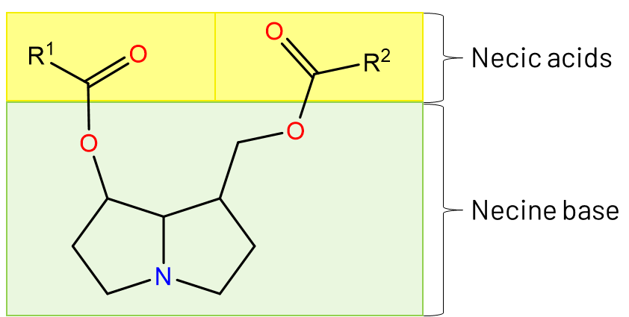
Structure
Pyrrolizidine Alkaloids
Background and research interests- Pyrrolizidine alkaloids (PAs) are secondary plant metabolites and natural toxins occurring in >6000 plants. They were found to exhibit carcinogenic and genotoxic properties following chronic exposure and hepatotoxic activity following acute poisoning in mammals. Human poisoning is typically caused by food or medicine contaminated with PA-rich weeds. The general structure of PAs consists of a necine base, that is esterified with on one or two necic acids, additionally they can be present as free base or as N-oxides. This results in a very high structural diversity with many isomers, by today more than 800 PAs are known.
In the European Union the maximum levels of 35 PAs for several plant-based food products are legislated. At the WFSR, where the EURL for plant toxins is located, about 80 standards of regulated and unregulated PAs are available. As those only represent a small fraction of the known, suspected and unknown PAs, a method using High Resolution Mass Spectrometry and molecular networking has been developed in order to annotate new PAs.
Objectives
The aim of the study is to annotate new PAs in a wide variety of plant species using HRMS and molecular networking.
Methodology/ what students can learn
After preparation of the plant extracts, the samples will be analyzed using liquid chromatography coupled to high resolution mass spectrometry. The data analysis will be done using Open Science tools, like Global Natural Product Social Molecular Networking. The influence of plant species, origin and part will be evaluated.
Requirements
We are looking for a MSc student interested in learning advanced analytical techniques, data analysis and gather knowledge about food safety. The project will have a duration of 6 months.

Contact information
Laura Righetti (laura.righetti@wur.nl) and Leonie Straub (leonie.straub@wur.nl)

